SIMATS ENGINEERING

ASSESSMENT TOOL 2

COURSE NAME: Cryptography and Network Security
COURSE CODE: CSA5117
NAME: Daniel Jesuraji J (192565085)
1. Create a concept map linking the following: Security Attacks, Threats, Risks and Security Goals (Confidentiality, Integrity, Availability. Perform the following tasks:
a. Show how each attack leads to specific threats and risks
b. Map how security goals help mitigate them Provide one real-world example for each link
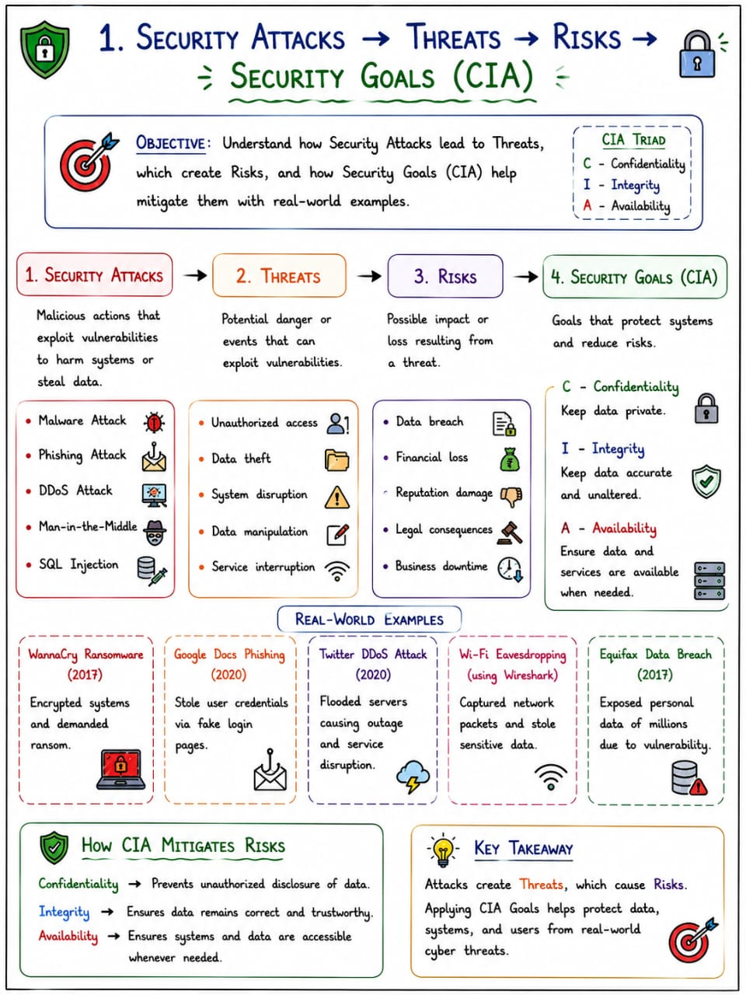
2. Develop a concept map comparing substitution techniques: Caesar Cipher, Monoalphabetic Cipher, Vigenère Cipher and Hill Cipher. Perform the following tasks to connect based on: Key usage, Complexity and Security strength. Analyze which technique is most secure and why.
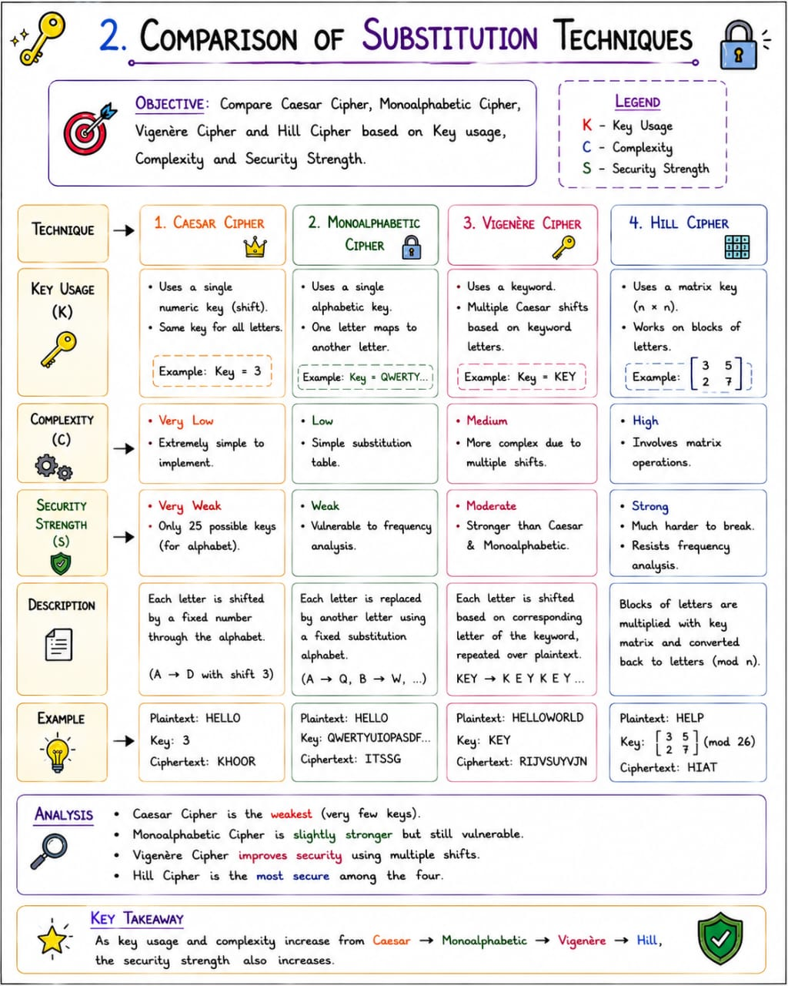

3. Construct a concept map for Classical Encryption Schemes: Substitution Techniques and
Transposition Techniques. Perform the following tasks:
a. Show differences and similarities
i.Map how each affects the Data structure and Security level
ii.Analyze which is more vulnerable to attacks and why
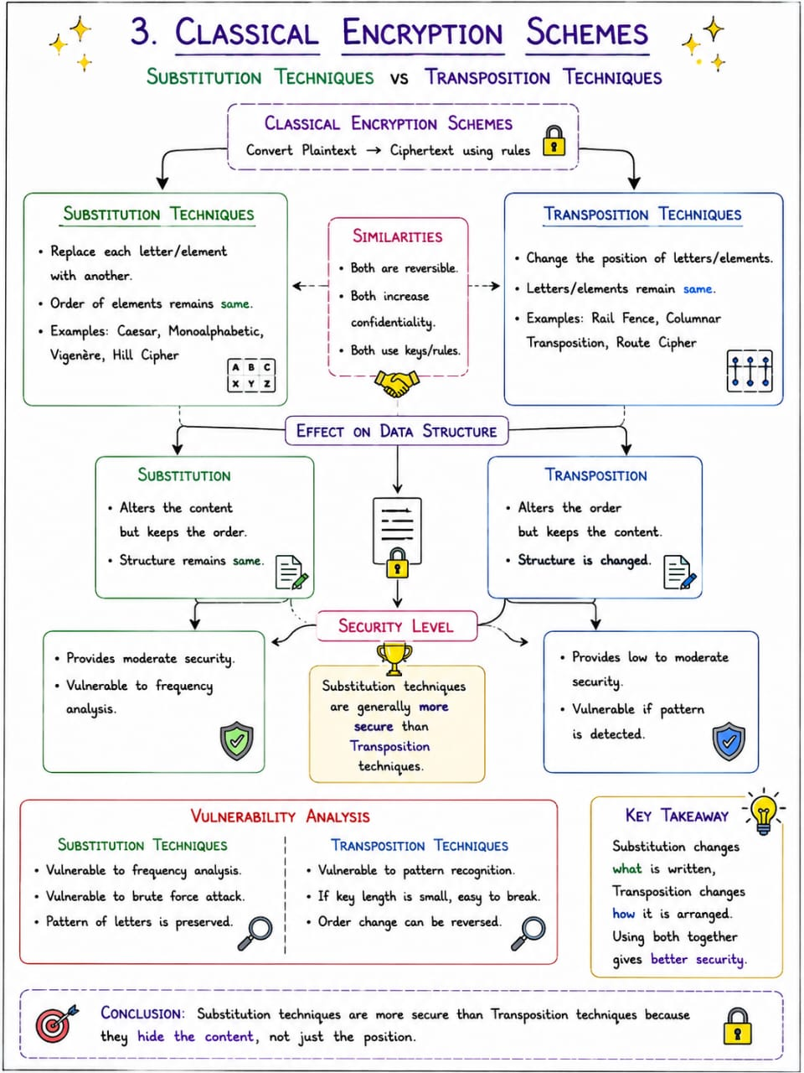

4. Create a concept map connecting Steganography concepts: Data Hiding, Watermarking and
Survivability. Perform the following tasks:
a. Show relationships between these concepts
b. Analyze how each contributes to secure communication
c. Include one real-world application for each
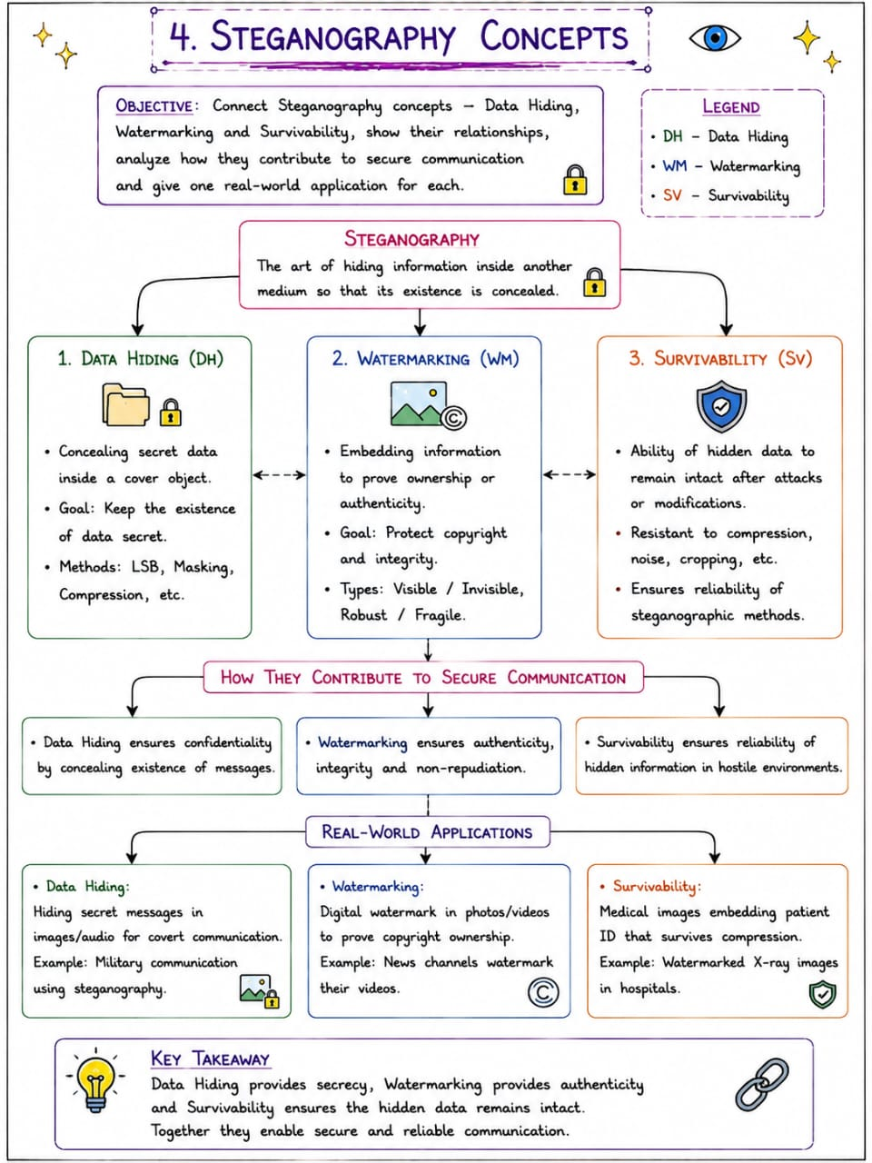

5. Draw a concept map linking number theory concepts used in cryptography: Modular Inverse, Extended Euclid Algorithm, Fermat’s Little Theorem, Euler’s Phi Function and Euler’s Theorem. Perform the following tasks:
a. Show how each concept is mathematically connected
b. Map their role in encryption/decryption
c. Analyze which concept is most critical for public key cryptography and justify
